1
Darktable User Interface
This chapter guides to the different aspects of the darktable user interface (UI). The first impact with darktable can seem a bit odd to a beginner who is used to other Linux applications. But after a little, darktable shows how its powerful user interface is also very easy to use. All sections and functionality are available in very fews clicks and many things can be done with very intuitive gestures.
Some concepts have been already introduced in the tutorial, this chapter will describe in more details all how to access all darktable features and functionality.

Darktable views
Darktable consists of three views, also called modes: lighttable view, darkroom view and camera tethering view. This section describes the first two, as they are the ones we spend most of our time. The latter view, tethering, will be presented later in the manual in the more advanced topics.

Lighttable view
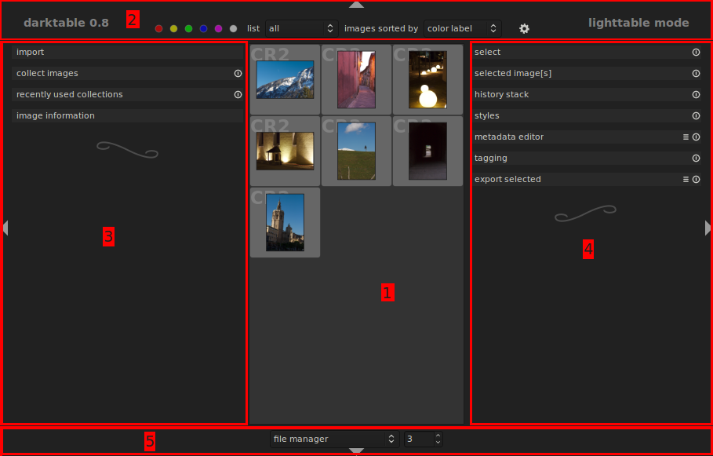Figure 1: Lighttable main window
Who comes from analog photography is probably already familiar with the concept of lighttable, but who comes from digital photography may not know that the light table is a real tool. A light table is a viewing table that is used to review photographic film or artwork placed on top of it. It provides even illumination of the subject from below through a translucent cover and fluorescent lights that emit little heat.
The same concept is used in darktable: lighttable is the mode where we organize and manage our “films” and developed photos. Again, “film” is a term taken from the times of analog photography, when photos were impressed on a film roll and therefore photos were naturally grouped by those films. In the digital era the concept of film roll is much weaker and represents a collection of photos that maybe we have taken at the same place or in the same day; at the same time, the concept of lighttable is here much wider: in darktable this view is where we group, rate, tag, colorlabel our photos. We can also easily apply the same set of development tasks to multiple photos and import and export images. All these functions are described in the following sections.
The main window has five different sections, highlighted in the screenshot above: (1) light table, (2) top bar, (3) left panel, (4) right panel and (5) bottom bar.
 | Press F11 to goes full-screen so that all window decorations will be hidden and darktable expands to all available space. Press F11 again to return to the normal window.  Press Tab to hide/show the left and right panel in once.
The top, bottom, left and right panels can be collapsed pressing the small arrow on the border of the panel () so to give more space to the light table.

The light table
The middle area of the main window is the light table. It is where all images (or better, all images in the selected collection as we will see later), are represented by their thumbnail.
When the main window is resized the light table resizes accordingly showing smaller or bigger thumbnails.
In addition to display a small version of the image, thumbnails bring also more information about the photo (metadata), which is shown when the mouse moves over it, as illustrated in Figure 2.
The top area of the thumbnail frame shows color labeling (the red, yellow and green dots), the image type (CR2) and if the image has been modified in darkroom (the symbol ). The bottom area of the frame shows the rating (3 of 5) given to the picture. To rate a picture we can simply click on the start that represents the increasing rate we give to the image. If the rate is 1 star, clicking on the first star will make the picture unstarred.
Figure 2: Thumbnail information
It is also possible to flag of a picture as rejected pressing the small in the bottom left corner. Starring will disappear and the cross becomes red. Clicking again on the reject button will make the picture back to unstarred so that it can be rated again.
When the mouse is over one thumbnail frame, the metadata can be manipulated with the simple key accelerators below:
1-5 | Change the rating from 1 to 5 stars. If pressed when rate is 1 the image becomes unrated.
F1-F5 | Toggle the colorlabel of the image: F1: red, F2: yellow, F3: green, F4: blue, F5: purple.
Ctrl-c | Copy the history stack of the image in the clipboard.
Ctrl-v | Paste (apply) the history stack from the clipboard to the image.
e | Open the image in darkroom for development.
z | Show the image in full screen mode.
An image can be selected clicking the left button on its frame and multiple images can be selected holding Ctrl when selecting.
There are two ways the light table displays thumbnails: file system and zoomable. When in file system mode, images can be scrolled up and down with mouse wheel and the up and down arrows keys. In addition, the same can be achieved pressing the keys w and s. Also pressing Ctrl while rolling the mouse wheel changes the number of thumbnails displayed on each row, resizing the thumbnail frame as appropriate.
When in zoomable mode, the light table shows all pictures (their thumbnails) in a single strip that can be navigated and moved in different ways. One is to use the arrow keys: the up and down keys move the strip down and up; the left and right keys move the highlighted image to the previous or next image, scrolling the strip if needed so to show the highlighted thumbnail in the light table. When in this mode, the mouse wheel zooms in and out the thumbnails and clicking on the strip and holding the right button, the strip can be dragged around the light table as needed.

Bottom bar
The purpose of the bottom bar is pretty simple. It allows to select the light table mode (file system or zoomable) and the maximum number of thumbnails to display in a row. Changing the number the images will be resized accordingly.

Top bar
The top bar has three purposes:
- apply or remove color labeling;
- specify sorting and filtering for the images to show in the light table;
- access darktable settings.
Selected images can be tagged/untagged with the wanted colors by clicking the colored dot in the top panel. A shortcut to remove all colors is clicking on the gray dot.

Another function of the top bar is to select which images show in the light table and in which order. As illustrated in Figure 3, images can be filtered by their rating and sorted by filename time, rating id and color label. Note that selecting for example to list all images with 2 stars will display all images with two or more stars.
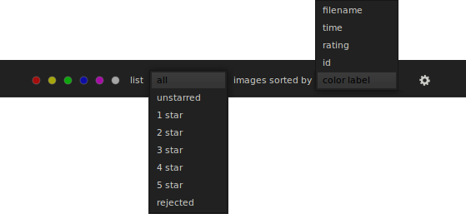Figure 3: listing and filtering options
Darktable settings can be accessed pressing the small button . In most of the cases default settings are appropriate and we do not need to change any parameter. A detailed description of the settings will be presented in the advanced topics sections of this manual.

Left and right panels
At the left and at the right of the light table there are two panels that collect most of the functionality of the lighttable view. Each functionality is delivered by a darktable panel. For example, Figure 4 shows the left panels.
For a detailed description of each panel, see TBD. Goal of this section is instead to familiarize with the basic darktable UI aspects.
Figure 4: Left side panels
The figure shows seven panels: select, selected image[s], styles, metadata editor, tagging and export selected. Select is expanded showing some other elements of the panel UI (he buttons select all, select none, invert selection, select film roll, select untouched). All other panels are collapsed so that only the panel title bar is shown. To expand (when collapsed) or collapse (when expanded) a panel just click on the panel title. For example, clicking on metadata editor, the panel is expanded as in Figure 5.
The menu button is used The panel title bar has three elements: the panel title, an optional menu (accessed through the button) and a reset button (). When the panel is expanded it can accommodate any darktable widget; the examples given in this sections are quite simple, but in the next chapters of the book, we will see more complex widgets and UI elements.
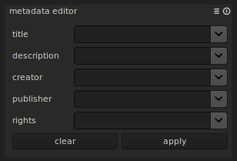Figure 5: metadata panel
Some panels are provided with a menu bar to access additional functionality of the panel. In the case of the metadata editor, the menu button brings the options in Figure 6.
The reset button is used to reset the panel parameters to its default values.
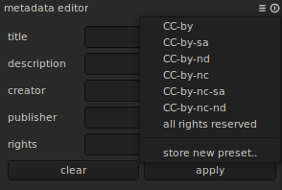Figure 6: metadata editor menu

Darkroom view
Those who come from analog photography should be familiar with the darkroom. A darkroom is a room that is dark and it is where we developed film. In darktable, the concept is very similar. In darktable we “develop” raw images. RAW images(.cr2, .nef, .dng ,etc.) are the digital version of film. Back in the days, after shooting a film, the film would have been developed in a darkroom with a well defined chemical process. In the darkroom, the film would be dodged and burned, exposure would be adjusted, etc. After that the film would have been put in the developing liquids and then after all those steps, the final image would come to life. Now, thanks to digital photography and RAW photo development software like darktable or “Adobe Lightroom”, all of these steps can be done on the computer.
Figure 7 below is a screenshot of what you will see when you enter darktable's darkroom mode. The window structure is similar to lightview; in darkroom, though, the middle area shows the picture that is under processing. The top bar is the same as in lighttable view and the two left and right panels contain the modules used to show photo information.
The bottom bar allows ...TBD ?? what is it for?? :) ...
To go back to lighttable at any time, press the accelerator key 'e' or click on the label “darkroom mode” in the top-right corner. A useful tool in darkroom mode is the filmstrip, just below the image. It is toggled pressing Ctrl-f and when visible shows the other photos available in the same film, so that it is easier to switch between images without exiting to lighttable and then back to darkroom.
Figure 7: Darkroom main window
The image in the middle area can be zoomed in and out pressing the Ctrl button and rolling the mouse wheel. In addition, Alt+1 and Alt+2 zoom the image to two per-defined zoom factors, while Alt+3 makes the image fit the available middle area.

Darkroom modules
The darkroom mode provides a number of general purpose modules which shows useful information on the picture under development and on the development process. The following sections describe in more details the modules of the left and right panels.
Darkroom modules have the same behavior of lighttable modules. For example, they can be expanded/collapsed clicking on the title bar, or reset settings to the default values clicking the reset button ().
Navigation
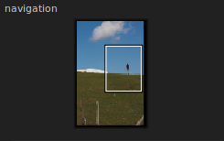Figure 8: navigation module
In the left panel, the navigation panel shows a small view of the entire picture and which part of it is currently displayed in the middle area (see Figure 8 ).

Snapshots
Often it is useful to compare the result of applying an effect with a snapshot of the image taken without that effect. This is what the snapshots module is for. Clicking on “take snapshot” a snapshot of what displayed in the main area is taken and added to the list of the snapshots. Selecting one of the snapshot will divide the photo area in two: the left part of the image shows the snapshot, the right half shows the current image. For example, Figure 9 shows a snapshot comparing the original image with a black and white version. It is possible to take more than one snapshot, even if it can be selected only one of them at a time.
Note that snapshots are not stored on disk. They will be discarded when darktable is closed.
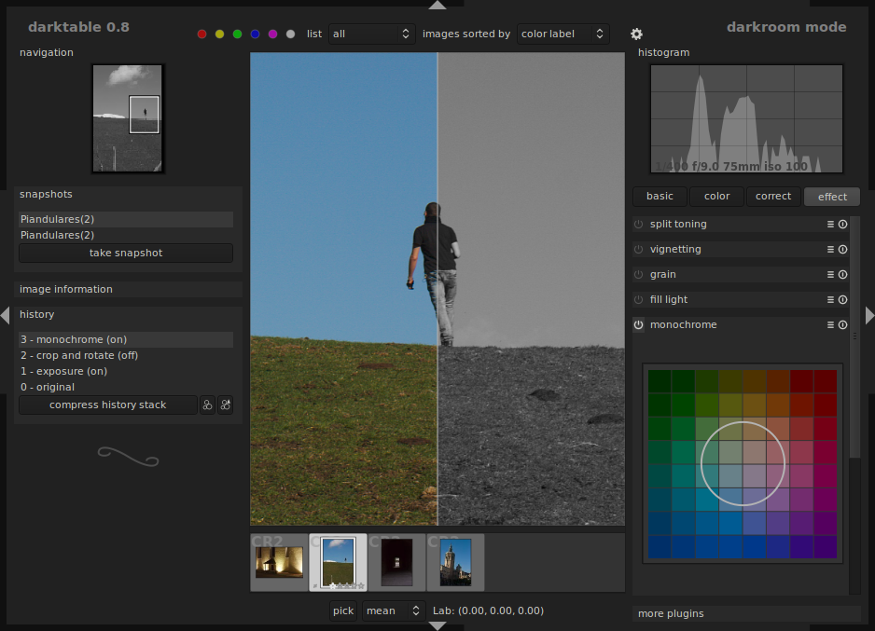Figure 9: snapshots module
Metadata
The metadata module shows meta data information about the image being processed. The parameters in the table below are shown in the metadata module.
Metadata field | Description
Filename | Picture file name on the disk
Model | Camera model
Maker | Camera manufacturer
Aperture | Aperture used to take the picture (e.g. F/8.0)
Exposure | Exposure used to take the picture (e.g. 1/100)
F-length | Focal length used (e.g. 50)
ISO | ISO used to take the picture (e.g. 100)
Date/time | Date and time of when the picture was taken (e.g. 2011:03:17 15:58:16)
Lens | The lens used (e.g. Canon EF 50mm f/2.5 Macro)
Width | Picture width (e.g. 3888)
Height | Picture height (e.g. 2592)
Film roll | The film roll the picture belongs to (e.g. 20110317)

History
The history stack is the stack of all processing and effects applied to the image. It always start with the original picture (0 – original) and then grows with the manipulations done on the pictures. Figure 10 shows the stack after adjusting the exposure and cropping the original image.
While manipulating the image we usually do not care too much the order in which we apply the effects. We can also turn on and off multiple times the same effect, making the stack grow but without affecting for real the image. It is therefore possible compress the stack to the minimum steps possible by clicking the “compress history stack”.
Figure 10: History stack module
A set of effects can also be stored in a style to be used later on other images. This functionality is better described later in the advanced section of this manual.

Histogram
The histogram of the photo being processed is displayed in the histogram module. As illustrate in Figure 11, the histogram shows the different light components and the basic shooting data (exposure time, aperture, focal length and ISO). The histogram is divided in two sections that are highlighted when the mouse pointer goes over the left or right sections. The histogram can be directly manipulated with the mouse, left-clicking and dragging left or right. Modifying the left part of the histogram will change the black point, while modifying the right section will change the exposure. Double clicking the histogram will reset black point or exposure to the original values.

Plugins
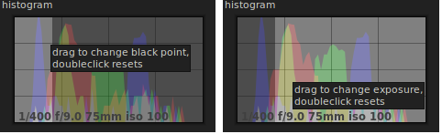Figure 11: Histogram module
Most of the area of the left panel is occupied by the plugins module. Plugins are the means to develop our digital images.
Plugins are grouped in basic, color correct and effect groups. Clicking on the group tab shows the plugins of the selected category, like illustrated in Figure 12. Clicking on the selected tab unselects all tabs and all plugins will be displayed.
Plugins UI is very similar to modules with the addition that they can turned on or off, meaning their effect is applied or not to the image. To switch on/off a plugin, just click the icon in the title bar.
Figure 12: plugin groups
Darktable plugins will be described in details in the next chapters.

More plugins
Plugins can be hidden from the plugins module. To hide/show a plugin, use the more plugins module (Figure 1) and click on the icon of the plugin to switch.
Highlighted plugins are displayed, darkened plugins are hidden.
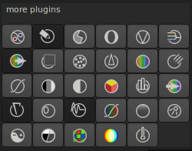Figure 13: more plugin module

